This lab is an interactive exercise with the instructor to familiarize you with some aspects of using a spreadsheet as a scientific calculator. Please follow the instructions presented by the instructor and take notes accordingly. *If you have your own laptop, please feel free to bring it and use it.*

**You will submit your work at the end of the lab.**

**Learning Objectives:**

After this lab you should be able to:

1) Be able to transfer data and plots between Excel and Word.

2) Construct formula relations to manipulate columns of data

3) Correctly plot and label ‘Scatter plots’

4) Calculate a numerical derivative from an arbitrary function or data set with respect to a given independent variable.

**Step 1**: Cell references and Formulas

Open up Microsoft Excel by going to the computer start menu and selecting Excel. Open up a new “blank workbook”. Open up a Microsoft Word document and open a new “blank document”. Save your Excel file as “Lab0_your_name” and save your Word file as “Lab0_your_name”. You will be copying material from the spreadsheet and pasting it in the Word document.

We will start with a discussion of the Excel menu bar.

Rows are labeled downward by number, columns are labeled to the right by letter. Examine the image below. Type your answers to all of the following questions in your Word document.

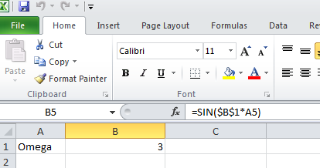Question 1) What does formula definition “=SIN($B$1*A5)” mean for cell B5?

Question 2) What do the dollar signs mean when placed before a row or column index?

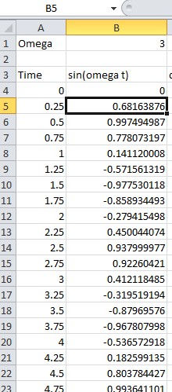

Examine the next figure to the right. The instructor will show you how to drag and copy a formula definition to produce two columns of data. The process of making a formula is straight forward and is common to several spreadsheet formats, including Excel and OpenOffice and various data analysis programs you may encounter. Please duplicate the instructors work on your machine.

To “drag”, use the left mouse button. Click on where you want to start and drag the cursor to where you want to go. The fill operations are found in the up left of the “Home” tab. You can fill (copy) formulas down, left or right, and if you want to create a sequence of numbers, use fill “series”. In the example below, “fill/series” has been used with a step value of 0.25 for the time series, and the data has been copied down in column B using the definition =sin($B$1*a4) in cell number B4, followed by a drag/fill/down copy of the definition to other cells. Excel automatically updates the reference a4 to a5, a6, a7, etc., as the column fill. But note that $B$1 remains unchanged in cell definitions.

Question 3) Write down what commands you would use to produce a time series with time increments of 2 seconds in cells A1 to A 25:

**Step 2**: Graphs and Plots

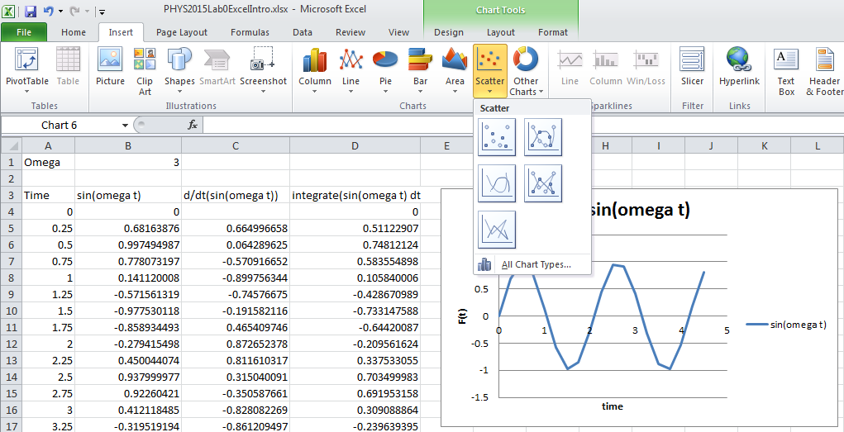Graphs are made by using the “insert” Menu. Make a graph similar to the one shown by following the directions given by the instructor using column A as the independent (x) variable and column B as the dependent (y) variable. Use a scatter plot with no markers and no interpolation. Make a plot title, and axis labels as shown by the instructor:

Copy and paste the graph from the Excel spreadsheet to the Word document. There are several ways to do this. Ctrl-C and Ctrl-V are easiest!

**Step 3:** Numerical Calculus

Spreadsheets can perform many mathematical tasks for manipulation of real data, including statistical operations, data analysis and calculus operations.

Although there are many better ways to perform calculus operations, your instructor will illustrate the basic components of the calculus of numerical analysis. Fundamentally, any numerical, computational package that you will use professionally has at its core the same basic means of manipulating the data to produce calculus results.

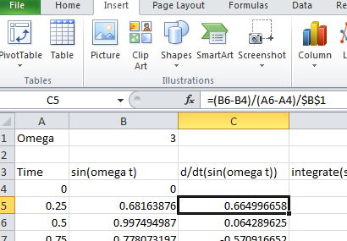**Step 3a Derivatives**: We start with the derivative function. Examine the definition of cell C5 in the figure to the left. The cell’s formula is defined at top in the *fx* line. It shows how to take a basic numerical derivative dy/dx *≈ y/x ≈* (B6-B4)/(A6-A4)  *is the approximate derivative for the function defined in column B corresponding to location B5 at the time A5.*  Note that the formula which defines C5 divides by $B$1. This term, $B$1 is just a constant. It represents the angular frequency ** of the *sin* function we are using, and I have put it in to “scale” the function so that it runs 0 to 1. Remember that the time derivative of *sin*(** *t*) would be * cos*(** *t*). Dividing by ** makes column C just record cos(** *t*). This is done for convenience in graphing multiple plots later in this lab.

The basic numerical approximation of the value of a derivative at a point is found by using Newton’s secant method. This is the same as finding the average slope or tangent at a point using the simple definition of a slope as the “rise over the run”, or *y/x*. Suppose your x-data or time data is in column A, and your function data is in column B. Suppose you want the derivative at row 6 of the data. Then putting the derivative data in column C, you would define C6= (B7-B5)/(A7-A5). Why C6 and not C5? Because you want C6 to be the average slope defined by the “point ahead” – the “point behind”. This means that defining the derivative for the cell C4 would be impossible with this definition, because there is no “point behind” in B3 and A3. There are other ways to deal with this problem, but we will simply leave the cell C4 blank for now, and not define a derivative for time A4. In any case, copying the formula found in C5 down the column length gives the derivative of column B as a function of the variable in column A, or as a function of time as we consider it here.

Question 4) Suppose you have a column of experimental data in column J and a column of positions for each experimental point in column K. What formula would you put in cell location H10 to find the numerical derivative at position 10 of column K of the data found in J? Write your answer in your Word document.

**Step 3b Integration**: An integral, on the other hand, is a measure of the area under the curve. One visualizes a rectangular chunk of area at some particular time ti as being y(ti) ti. The integral would be the sum of all such points: y(ti) ti. Suppose you wanted the integrand at data row six, and you wanted to put the result in column D, then you’d write something like: D6=B6*(a6-a5). But, be careful! Since the integral is the sum of all such “bits” of area, you’d need to add the previously calculated integrands, so the correct formula for D6 would be D6= B6*(a6-a5)+D5!

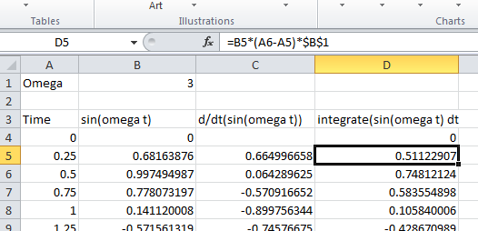

Question 5) Examine the definition for cell D5 shown in the figure to the right. It does not give the correct form for tallying the integral. How would you change it to give the “integral” of the data? Write your answer here:

Can you figure out why the term $B$1 is multiplying the term B5*(A6-A5)? If you can, give the answer in your Word document.

Now make a triple plot of all three functions found in columns B, C and D following the example of your instructor. They should look like those shown in the figure below. Once you have made your plot, with appropriate labels, please copy and paste it into you open Word document.

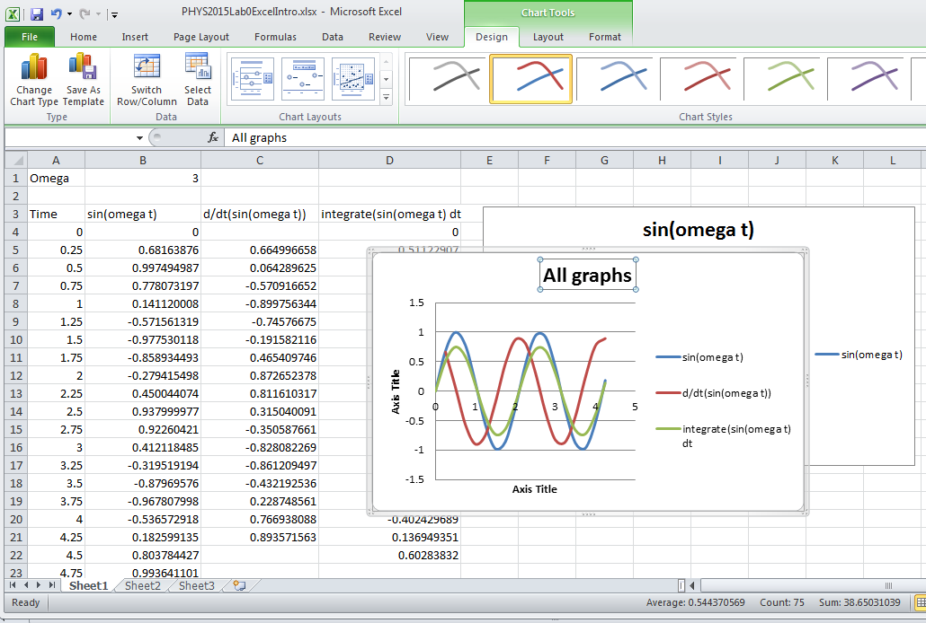

**Step 4 Calculus with real data! Do it yourself**!

Any real data set contains sources of error, noise, or variations in the measured signal that are a distraction from the central physics of the experiment. We will explore more about errors in a later lab, but consider the following data set and graph. The blue line is the data and the red line is a “smoothed” version of the same data

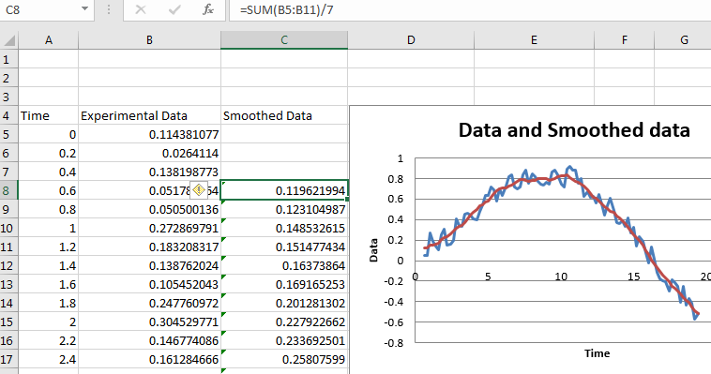There is clearly a rapid ‘jitter’ around or about a more smoothly varying function. Taking a derivative, the raw data would produce numerical nonsense. The slope would be at times infinite, and vary erratically. Clearly it would be ‘fair’ to manipulate this data to remove the high frequency noise if it were the underlying smoothly varying function that was of interest. This calls for “smoothing the data”. There are many ways to smooth data, but one of the easiest is to smooth it by taking a running average. Consider the definition in the cell C8 which is defined as “=SUM(B5:B11)/7”. This smooths the data by averaging over the seven data points surrounding any one point. The red line in the figure shows the result of the smoothed function. This smoothed function may still contain “errors” or noise, but it is clear that the underlying smooth function is more readily adaptable to further analysis.

In the coming weeks you will be taking many measurements with electronic sensors that do smoothing or other data massaging automatically, all along without telling you! –One practical lesson you should learn from this is to never trust an electronic measurement unless you know exactly how the measurement is being made, and what manipulations are performed on the signal before you see it! This is critical point of understanding to the success of any scientist or engineer in any field! (And a point which is so often lost on technicians, health professionals, environmentalists, business people and especially politicians – sorry for the rant!)

Consider now calculus operations performed on the smoothed experimental data. One extremely important thing to know about differentiation is that it is an error-multiplying operation. Small errors are amplified, because in taking the difference *yj = xj+1 - xj-1*, the errors associated with each data point remain while most of the signal is subtracted away! This is clearly visible in the figure below showing the derivative of the smoothed data. See how jagged the slope data is. It looks almost as if smoothing had never been done! A trend line has been added to the graph to suggest a more useful interpretation of the slope data.

On the other hand, Integration is inherently an error-reducing operation. Since the integral is essentially a successive sum of points, the random nature of “noise” cancels out since there is as much “positive” noise as “negative”. This is also clearly seen in the figure below, on the right for the integral of the data. The line is a smooth as can be! (One lesson to learn is that if you can set up your experiment to be the result of an integration process, you win!)

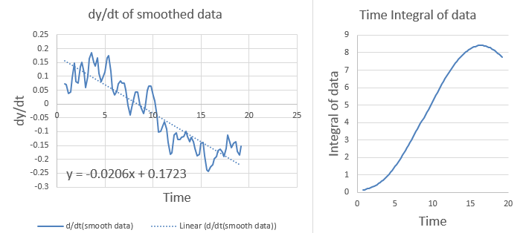

**Do it yourself!** Your lab instructor may choose to supply each of you with an electronic sensor and a means of collecting a set of data to manipulate. If so, follow their instructions. If no sensor is provided, then download the file ‘Lab0experiment.csv’ from the canvas website. Open the file in Excel and copy and paste the data columns that you find there into a new worksheet in your Excel ‘Lab0’ workbook.

Whether you are using data that you collected yourself, or that provided in the file, smooth the data over 5, 7 or 9 data elements (your choice) as described above. Then produce a graph similar to the one showns above, including a graph of the raw data and its smoothed function, a graph of the derivative of the smoothed function and a graph of the integral of the function. When you have labelled it appropriately, copy and paste the graphs into your Word document.

Save your spreadsheet. Make sure that all the questions have been answered in your Word document. Put your name and your lab partner’s name on your Word document. Print it out on printer in PS-108. It will be scanned for completeness of responses and returned to you next week. The final score (on a scale of 0 to 10) will be recorded in Canvas.

Then finally, email a copy of your spreadsheet. You must use exactly the correct format if you want credit.

Address the email to:

[phil.matheson@uvu.edu](mailto:phil.matheson@uvu.edu)

In the subject line of the email use the exact format if you are in section 201, substituting actual names for those indicated:

Lab0 Section 201 (Your name) (Your partner’s name)

Or for section 205:

Lab0 Section 201 (Your name) (Your partner’s name)

If you do not follow this format, or if you send it to some other address, you will not get credit for the lab.

Don’t forget to download the lab for next week on Friday, and do the online quiz before coming to class next week.